4CS015 Fundamentals of Computing – Workshop-6

Workshop tasks:
- Von Neumann Simulator. This program simulates a very simple computer with the von Neumann architecture.
  - Download the von Neumann Simulator (VonNeumann.exe) program from WOLF in the Week 5 folder. Save it in your Documents folder and run it. You will see a window similar to this:
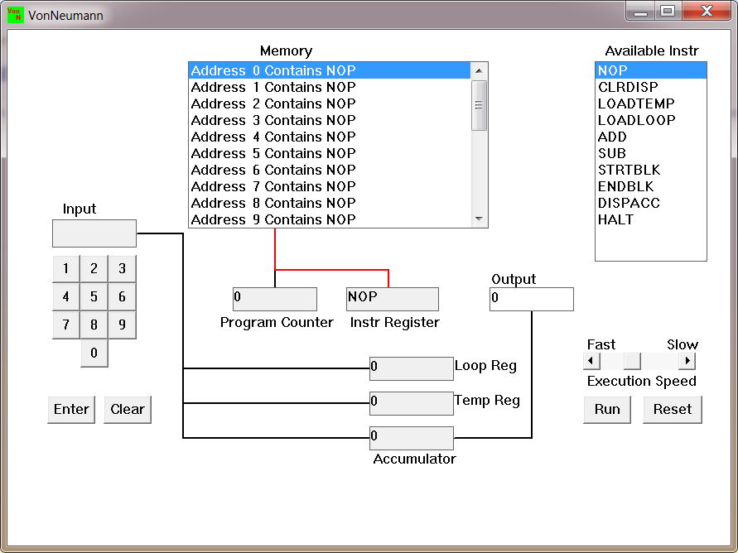
The simulator has a small program memory area which is available for programming. To enter your program instructions simply click on the “Available” instruction on the list on the right and then click on the “Memory” location you wish to put it in.

This simulator understands only the following ten instructions:
NOP | No Operation, i.e. do nothing.
LOADTEMP | Get a number from the keypad, completed by the Enter key, into the Temporary Register.
LOADLOOP | Get a number from the keypad, completed by the Enter key, into the Loop Register.
CLRDISP | Clear the Display.
ADD | Add the Temporary Register to the Accumulator
SUB | Subtract the Temporary Register from the Accumulator
DISPACC | Display the contents of the Accumulator
STRTBLK | Start of Loop Block
ENDBLK | End of Loop Block
HALT | Halt. Stop Program

  - Load the following program into the memory:
LOADTEMP
ADD
DISPACC
HALT
To do this, first click on the “LOADTEMP” in the list of instructions on the right of simulator window. Then click on Memory location with “Address 0 Contains NOP”. This will then change into “Address 0 Contains LOADTEMP”. Repeat the process with “Address 1” and so on until the whole program is loaded.
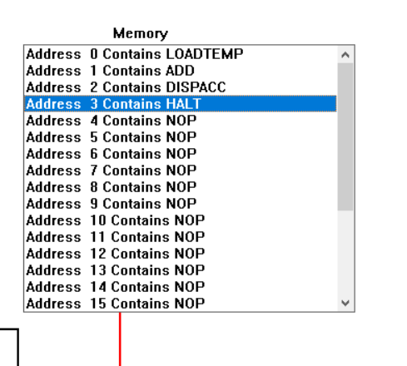
  - Run the program by clicking on the “Run” button. The simulator would highlight the Address 0 location and then pause. It is executing the instruction “LOADTEMP” which requires you to input a number into the keypad.
Click 2 or 3 numbers on the keypad and then click the “Enter” button. The simulator will then resume running the program and execute the instruction “ADD”. This adds the number that you just entered, to the zero in the accumulator.
The next instruction is “DISPACC” which stands for “Display Accumulator”, and it does exactly that. After than the simulator stops running the program when it executes the instruction “HALT”.
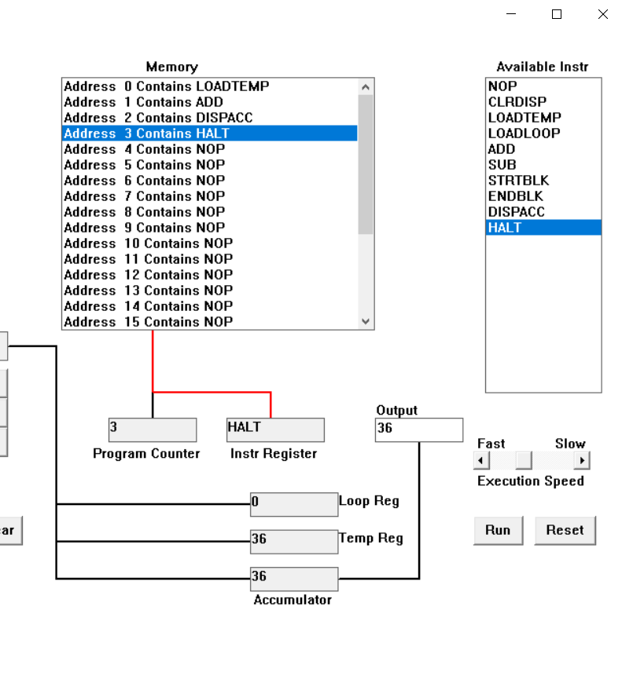
  - Load the following program into the simulator:
LOADTEMP
ADD
LOADTEMP
ADD
DISPACC
HALT
What do you think it does? Write your answer below (10 marks)
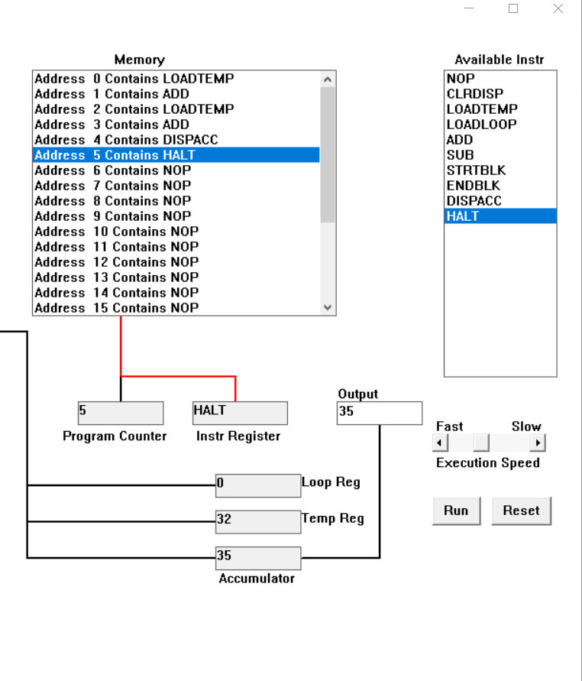
First, Loadtemp loads the number that is given through the input.
The program counter becomes 0 as the LOADTEMP is on address 0 and LOADTEMP comes to instr Register. After typing a number it is loaded to temp reg.
Then program counter becomes 1 where in Instr Register the instruction becomes ADD. The given input number gets added to the accumulator.
Then the program counter becomes 2 and in Instr Register LOADTEMP instruction is loaded whereby after giving a certain number as input it gets registered to temp reg.
Then the program counter becomes 3 and in Instr Register ADD instruction is played out whereby the input of previous one in accumulator gets added to the input given at the instruction number 2, thus adding the two number.
The program counter displays address of 4 and in Instr Register the instruction is DISPACC whereby it displays the output, in this case 35 in the Output column.
Then in Program counter the count is of 5, and in Instr Register the instruction is of HALT, which stops the program altogether.
  - Write a program to add 3 numbers together. List your program below (10 marks)
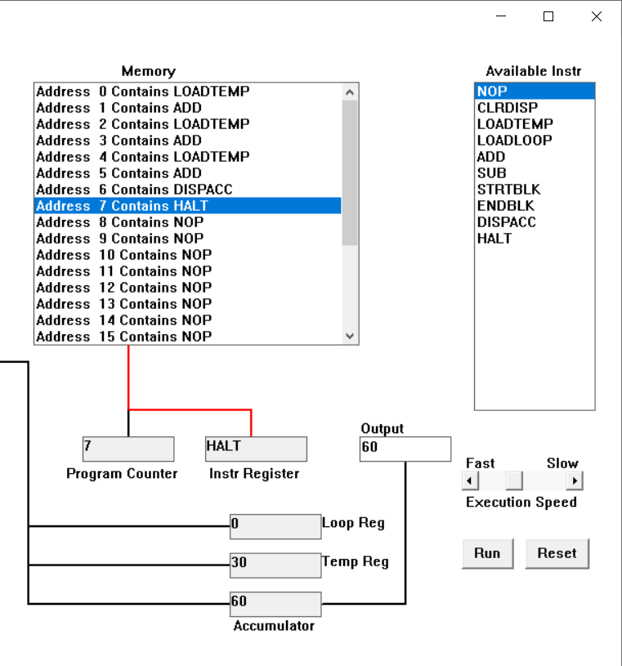
First, Loadtemp loads the number that is given through the input.
The program counter becomes 0 as the LOADTEMP is on address 0 and LOADTEMP comes to instr Register. After typing a number it is loaded to temp reg.
Then program counter becomes 1 where in Instr Register the instruction becomes ADD. The given input number gets added to the accumulator.
Then the program counter becomes 2 and in Instr Register LOADTEMP instruction is loaded whereby after giving a certain number as input it gets registered to temp reg.
Then the program counter becomes 3 and in Instr Register ADD instruction is played out whereby the input of previous one in accumulator gets added to the input given at the instruction number 2, thus adding the two number.
The program counter displays address of 4 and in Instr Register the instruction is LOADTEMP whereby it takes another input and stores it in Temp Reg.
Then in Program counter the count is of 5, and in Instr Register the instruction is ofADD, which adds the input taken from program counter number 4 into the number present in accumulator and stores it there.
The program counter displays address of 6 and in Instr Register the instruction is DISPACC whereby it displays the output, in this case 60 in the Output column.
Then in Program counter the count is of 7, and in Instr Register the instruction is of HALT, which stops the program altogether
  - Write a program to subtract a number from another. List your program below (10 marks)
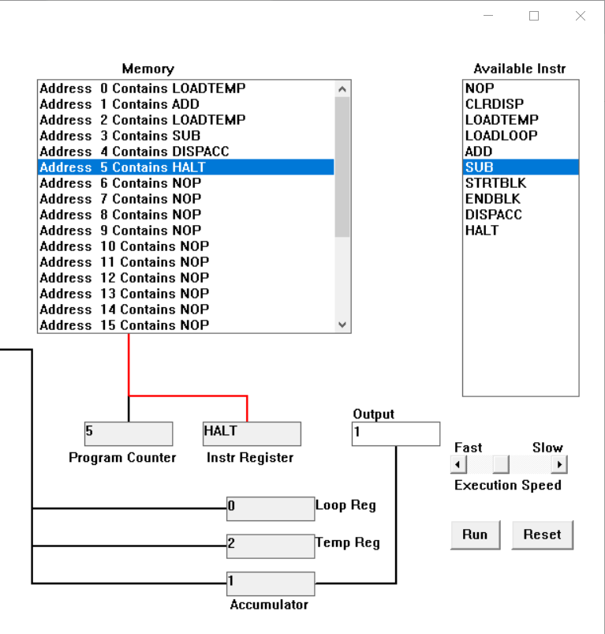
The program counter becomes 0 as the LOADTEMP is on address 0 and LOADTEMP comes to instr Register. After typing a number it is loaded to temp reg.
Then program counter becomes 1 where in Instr Register the instruction becomes ADD. The given input number gets added to the accumulator.
Then the program counter becomes 2 and in Instr Register LOADTEMP instruction is loaded whereby after giving a certain number as input it gets registered to temp reg.
Then the program counter becomes 3 and in Instr Register SUB instruction is played out whereby the input of previous one in accumulator gets subtracted from the input given at the instruction number 2, thus subtracting the two number.
The program counter displays address of 4 and in Instr Register the instruction is DISPACC whereby it displays the output, in this case 1 in the Output column.
Then in Program counter the count is of 5, and in Instr Register the instruction is of HALT, which stops the program altogether.
  - Load the following program into the simulator:
LOADTEMP
ADD
LOADLOOP
STRTBLK
ADD
DISPACC
ENDBLK
HALT
Run it and when it reach the LOADTEMP instruction, enter 5 on the keypad and click the “Enter” button. When it reaches the LOADLOOP instruction, enter 6. What do you think the program does? Write your answer below in the form of an equation (10 marks)
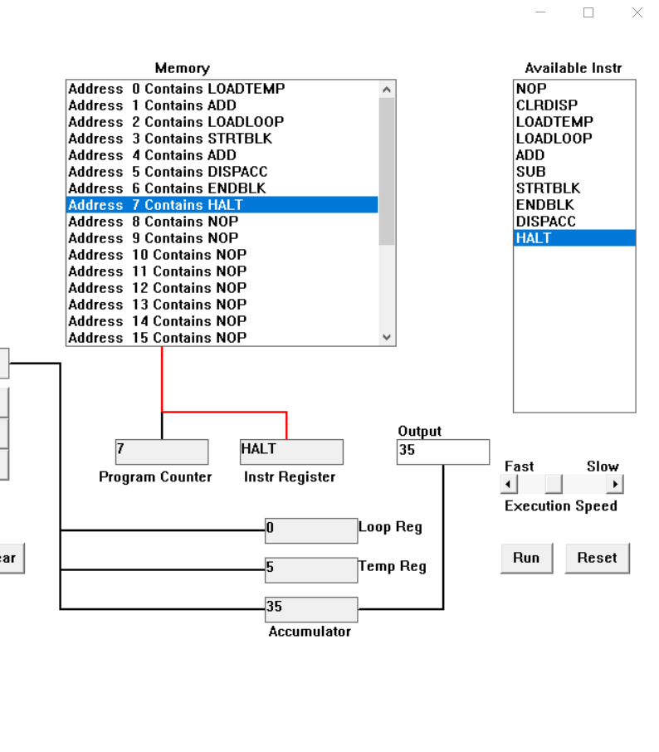
LOADTEMP temporarily displays the number 5 after the program counter displays 0 and Instr Register displays LOADTEMP.
Then program counter displays 1 and Instr Register displays ADD, which adds the number 5 to 0 of Accumulator.
Then the program counter displays 2 and in Instr register, the instruction is of LAODLOOP which temporarily stores 6 and stores the loop and gives the instruction that the loops need to be run for 6 total time.
And then program counter becomes 3 and Instr Register becomes STRTBLK which starts the block of loop and the program counter becomes 4 and Instr register becomes ADD which adds 5 to the existing 5 at the accumulator and the program register becomes 5 which displays the number of the end result.
The loop then runs for total of 6 times making the end result of 35.
In the form of equation:
5+(5*6)
  - Write a program that will let you add 5, or 10 or 20 numbers together. List your program below and explain how it works (25 marks)
To add a number 5 times (let that number be 5):
Program counter: 0 Instr Register: LOADTEMP
5 gets loaded in Temp Reg
Program counter: 1 Instr Register: LOADLOOP
When 5 is added as input it says the loop to run for 5 times.
Program counter: 2 Instr Register: STRTBLK
Starts the loop
Program counter: 3 Instr Register: ADD
This begins to add 5 to 5 for a time
And as it is loop the program counter returns to the previous one and the loop runs for 5 times adding a number that is in this case 5 for 5 times.

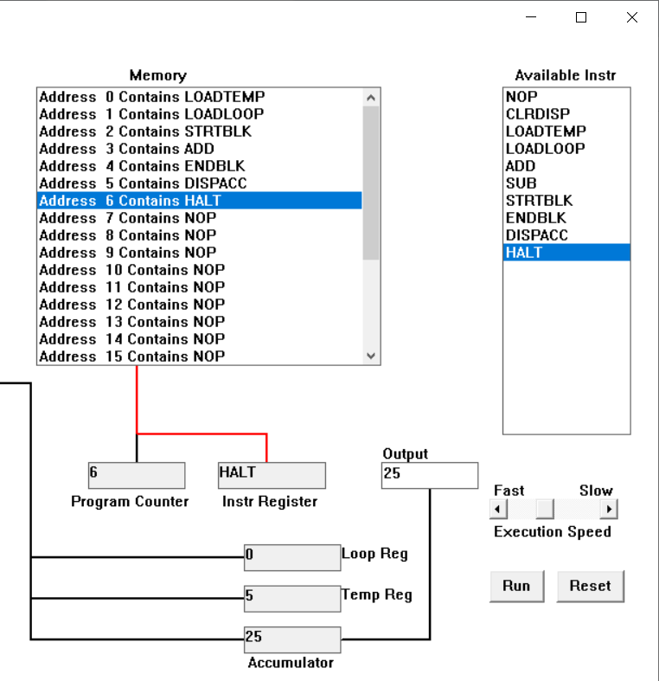
To add a number 10 times (let that number be 5):
Program counter: 0 Instr Register: LOADTEMP
5 gets loaded in Temp Reg
Program counter: 1 Instr Register: LOADLOOP
When 10 is added as input it says the loop to run for 10 times.
Program counter: 2 Instr Register: STRTBLK
Starts the loop
Program counter: 3 Instr Register: ADD
This begins to add 5 for 10 time
And as it is loop the program counter returns to the previous one and the loop runs for 10 times adding a number that is in this case 5 for 10 times.
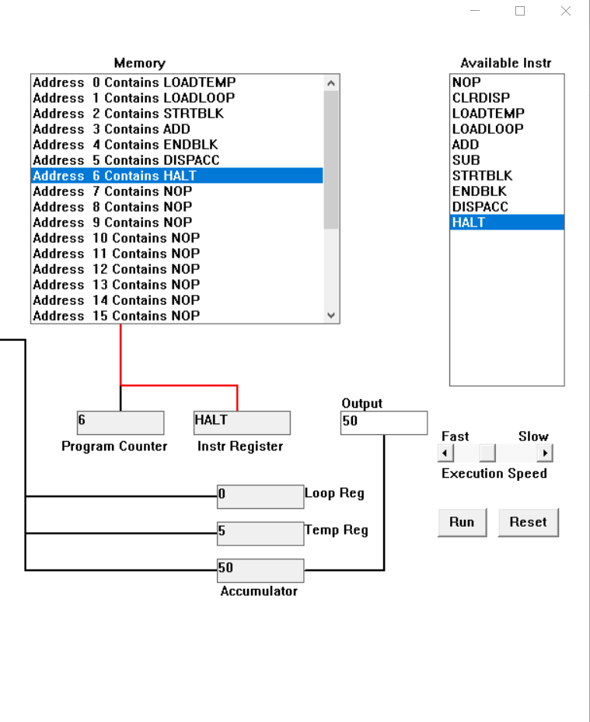
To add a number 20 times (let that number be 5):
Program counter: 0 Instr Register: LOADTEMP
5 gets loaded in Temp Reg
Program counter: 1 Instr Register: LOADLOOP
When 20 is added as input it says the loop to run for 20 times.
Program counter: 2 Instr Register: STRTBLK
Starts the loop
Program counter: 3 Instr Register: ADD
This begins to add 5 for 20 time
And as it is loop the program counter returns to the previous one and the loop runs for 20 times adding a number that is in this case 5 for 20 times.
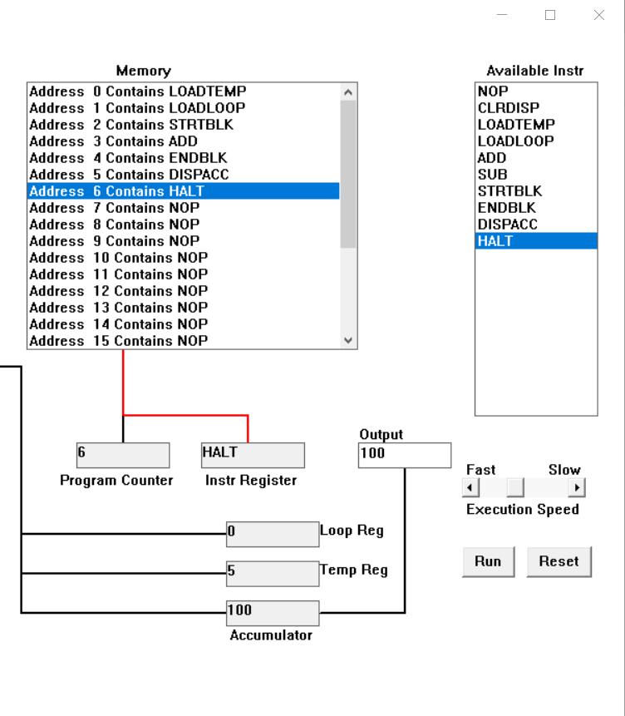

  - Write a program that will let you multiply 2 numbers together. List your program below and explain how it works (35 marks)
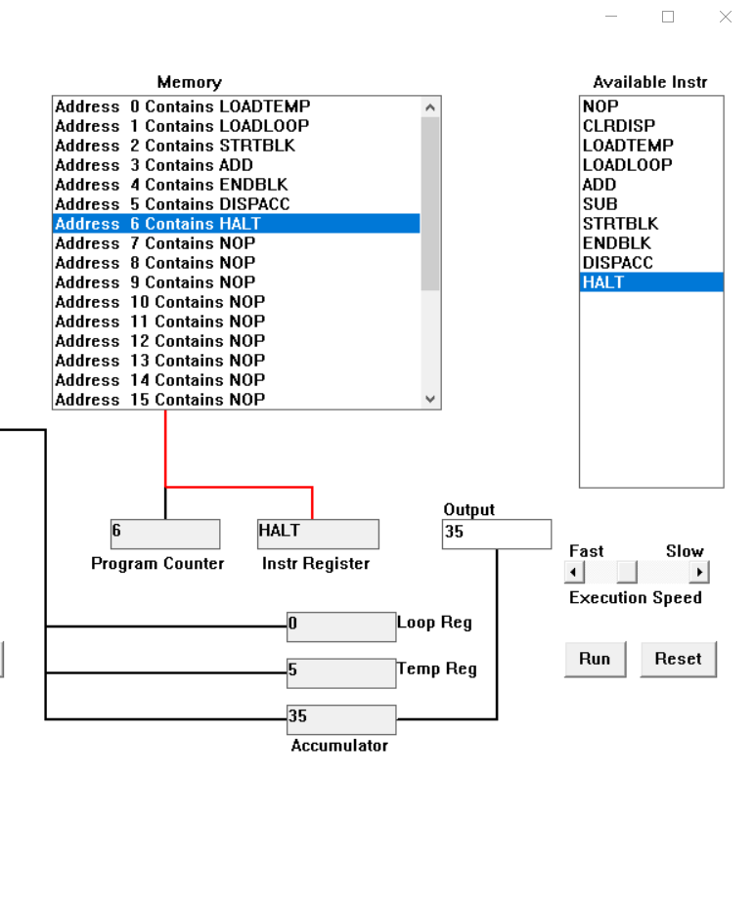
To multiply two numbers (let that number be 5 and 7):
Program counter: 0 Instr Register: LOADTEMP
5 gets loaded in Temp Reg
Program counter: 1 Instr Register: LOADLOOP
When 7 is added as input it says the loop to run for 7 times meaning add 5 to 5 for 7 times which is 5*7 or 7*5, thus meaning to multiply 5 for 7 times.
Program counter: 2 Instr Register: STRTBLK
Starts the loop
Program counter: 3 Instr Register: ADD
This begins to add 5 for 7 time which is to say multiplies 5 for 7 times.
And as it is loop the program counter returns to the previous one and the loop runs for 7 times adding a number that is in this case 5 for 7 times thus being 5 *7 or 5*7 which is multiplying two numbers.
At last, the output displays the end result.
Thus, by this method we could multiply two numbers.

